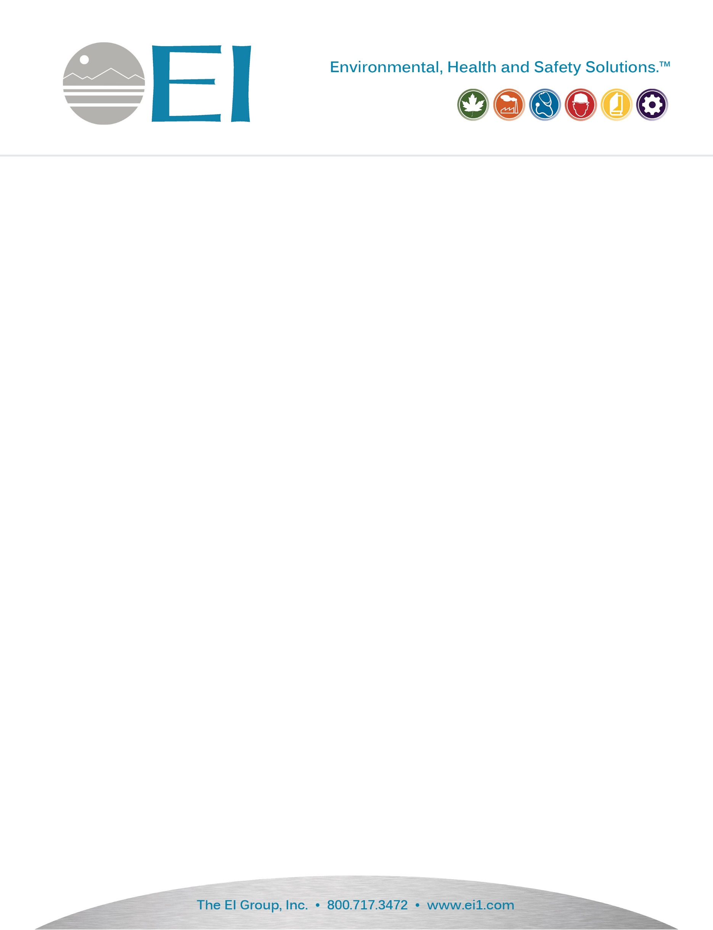

May 10, 2021

Dewberry Engineers, Inc. – ReBuild Phase 2

1545 Peachtree Street NE

Atlanta, Georgia 30309

**RE: Limited Asbestos Inspection-Roofing Materials**

**6950 NC 87 West, Battleboro, North Carolina**

**EI Project No: IHMO210107.00**

**ReBuild NC Batch ID: APP-01373, INSP-0004415**

Dear Mr. Richard Rivera:

Per the contract outlined by The North Carolina Office of Recover and Resiliency (NCORR), The EI Group, Inc. performed a limited asbestos inspection of the residence located at 6950 NC 87 West in Battleboro, North Carolina. The inspection was performed by Mr. Brian Long (NC Asbestos Inspector #13256) on April 30, 2021 and limited to suspect roofing materials not included in the scope of EI’s previous asbestos inspection of the residence performed on November 24, 2020.

**Methodology**

An appropriate number of samples, per the AHERA protocol, were collected and submitted for analysis Eurofins CEI Analytical, Inc. who is an accredited laboratory (NC NVLAP) located in Cary, North Carolina. Samples were analyzed by the Environmental Protection Agency (EPA) 600/R-93/116 Method using Polarized Light Microscopy. Per the EPA if any homogenous material contains >1% asbestos by weight that material is considered asbestos containing and is therefore regulated.

Occupational Safety and Health Administrations (OSHA) considers any percentage of asbestos fiber in building material as a hazard and the building owner must ensure demotion contractor adhere all OSHA regulations regarding building materials containing asbestos fiber.

**Findings/Results**

Suspect asbestos-containing materials that were visible/accessible from the residence’s ground level perimeter consisted of the following:

* Brown Roofing Shingle & Black Tarpaper

Of the suspected asbestos containing material/s collected, none were found by analytical analysis to be regulated asbestos materials (>1% by weight).

**Conclusion/Recommendations**

Any additional suspect materials identified outside of this survey should be presumed positive for ACM until further testing is completed.

Enclosed, please find copies of all chains of custody, and laboratory analytical data.  If you have any questions regarding this information, please feel free to contact me at your earliest convenience.

Sincerely,

The EI Group, Inc.

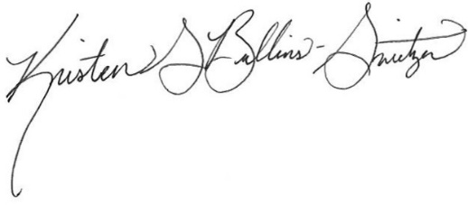

Kristen Switzer

Industrial Hygienist

Appendix A: Chain of Custody & Laboratory Analytical Data

Appendix B: Certifications & Licensure

Appendix C: Photographs

**Appendix A: Chain of Custody & Laboratory Analytical Data**

**Appendix B: Certifications & Licensure**

**Appendix C: Photographs**